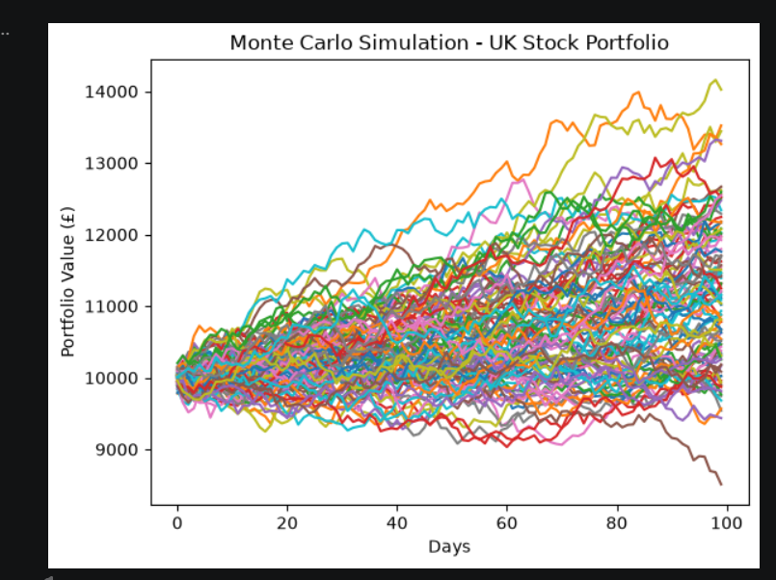In quantitative finance, this is affectionately called a Spaghetti Chart.
Instead of trying to predict the exact future (which is impossible), your machine just ran 100 highly realistic, alternate universes and plotted them all on top of each other.
Here is the exact mechanical breakdown of what this graph is telling you:
1. The Origin Point (The Pinch)
Look at Day 0 on the left side. Notice how every single one of the 100 lines is perfectly pinched together exactly at the £10,000 mark. This is your initialPortfolio variable. Because Day 0 is "today", there is zero uncertainty. Every universe starts with the exact same amount of cash.
2. The Individual Lines (The Alternate Universes)
Every single colored line represents one full completion of your for loop (one specific value of m).
- The machine took your £10,000, rolled the dice to simulate Day 1's random shocks, applied the mechanical linkage (covariance) to your 6 stocks, added the baseline drift, compounded the interest, and plotted the new portfolio value.
- It did that 100 times in a row to draw one line.
- Then it went back to £10,000 and drew the next line.
3. The "Cone of Uncertainty" (Variance)
Notice how the lines fan out into a massive cone shape the further to the right you go?
- In engineering and statistics, uncertainty compounds over time. Predicting what the market will do tomorrow is relatively tight (the lines are still clustered together at Day 10).
- Predicting what it will do 100 days from now is highly chaotic. The mechanical shocks have compounded so many times that the variance has expanded massively.
4. The Extremes (Best and Worst Case Scenarios)
If you look at the right edge (Day 100), you can see the absolute limits of your simulation:
- The Top Line (The Lucky Universe): One simulation got extremely lucky with consecutive positive random shocks, pushing your £10,000 past £14,000.
- The Bottom Line (The Unlucky Universe): Down at the very bottom, one simulation suffered a brutal sequence of negative shocks, dragging your portfolio down to roughly £8,500.
- The Center of Mass: The thickest, messiest cluster of lines right in the middle (around £10,500 to £11,500) shows you the highest probability outcome. Because your baseline drift (meanReturns) was likely positive, the center of gravity for the whole cone drifts slightly upward over time.

1. The Computer's "Fake" Randomness (PRNG)
First, a candor check: Computers cannot generate true randomness. A computer is a perfectly deterministic calculator; if you give it an input, it gives the exact same output every single time.
To fake a dice roll, Python uses a Pseudo-Random Number Generator (PRNG). Deep inside NumPy's engine, there is a massive, highly complex mathematical formula.
- It grabs a "seed" (usually the microscopic exact millisecond on your computer's internal clock).
- It violently scrambles that timestamp through a mathematical blender (modern NumPy uses an algorithm called PCG64).
- It spits out a decimal that looks entirely unpredictable to a human.
2. The Shape of the Randomness (The Ziggurat Algorithm)
If NumPy just spat out raw, unshaped random numbers, they would be "Uniform." That means a +10% stock jump would happen just as often as a +0.1% jump.
When you wrote np.random.normal(...), you applied a physical filter to that PRNG. Python uses an advanced filtering technique (often the Ziggurat algorithm) to bend those raw numbers into a Gaussian Bell Curve.
Here is the exact principle of how it filters the chaos:
- The Mean (0): The system heavily biases the output toward zero. It mathematically guarantees that the vast majority of the random days it simulates will be incredibly boring (e.g., +0.1%, -0.2%).
- The Standard Deviation (1): It dictates how fast the probability drops off. A 1-standard-deviation event (a normal busy day) happens roughly 68% of the time. A 3-standard-deviation event (a massive, violent market shock) is mathematically choked off so it only happens about 0.3% of the time.
3. The Isolation (White Noise)
When your code executes Z = np.random.normal(size=(T, len(weights))), it stamps out 600 of these bell-curve numbers (100 days $×$ 6 stocks).
At this exact millisecond in the code, the randomness is completely isolated. The random number generated for Barclays has absolutely zero awareness of the random number generated for BP. In physics and signal processing, this pure, unlinked chaos is called White Noise.
4. Forcing the Chaos to Behave (The Linkage)
This is the final, most crucial step in your simulation. Pure white noise does not exist in the stock market. If a global event crashes the market, BP and Shell are going down together.
Your code does not leave the randomness as white noise. It takes that pure, independent chaos ($Z$) and smashes it into your Cholesky linkage matrix ($L$).
Because of the matrix multiplication (np.inner(L, Z)), the simulation takes the random shock assigned to BP and physically bleeds a mathematically precise percentage of it over into Shell, based entirely on their historical covariance.
Summary of the Principle:
The randomness in your code is a mathematically sculpted illusion. It starts as a fake, clock-based dice roll, gets bent into a realistic bell curve of probabilities, and is finally welded together by linear algebra so the random shocks perfectly mimic the interconnected gravity of the real-world stock market.

